Torredemer
2026-05-25
library(car)
## Warning: package 'car' was built under R version 4.2.3
## Loading required package: carData
## Warning: package 'carData' was built under R version 4.2.3
library(readr)
## Warning: package 'readr' was built under R version 4.2.3
DB_ea_sports24_afterprocessing <- read.csv("C:/Users/Paco/Documents/TFM/bases_de_datos/DB_ea_sports24_afterprocessing.csv", sep=";")
fifa_after <- DB_ea_sports24_afterprocessing
df <- fifa_after
names(df)
## [1] "team_name" "league_name" "top_league"
## [4] "nationality_name" "overall" "attack"
## [7] "midfield" "defence" "home_stadium"
## [10] "def_style" "def_team_width" "def_team_depth"
## [13] "off_build_up_play" "off_chance_creation" "off_team_width"
## [16] "off_players_in_box"
#MODELO LINEAL 0 (solo overall)
m0 <-lm(df$overall~1, data=df)
summary(m0)
##
## Call:
## lm(formula = df$overall ~ 1, data = df)
##
## Residuals:
## Min 1Q Median 3Q Max
## -13.4043 -3.4043 -0.4043 2.5957 16.5957
##
## Coefficients:
## Estimate Std. Error t value Pr(>|t|)
## (Intercept) 68.4043 0.1949 350.9 <2e-16 ***
## ---
## Signif. codes: 0 '***' 0.001 '**' 0.01 '*' 0.05 '.' 0.1 ' ' 1
##
## Residual standard error: 5 on 657 degrees of freedom
mean(df$overall)
## [1] 68.40426
sd(df$overall)
## [1] 4.999919
#MODEL LINEAL 1 (overall - attack)
names(df)
## [1] "team_name" "league_name" "top_league"
## [4] "nationality_name" "overall" "attack"
## [7] "midfield" "defence" "home_stadium"
## [10] "def_style" "def_team_width" "def_team_depth"
## [13] "off_build_up_play" "off_chance_creation" "off_team_width"
## [16] "off_players_in_box"
m1 <- lm(overall~attack, data = df)
summary(m1)
##
## Call:
## lm(formula = overall ~ attack, data = df)
##
## Residuals:
## Min 1Q Median 3Q Max
## -8.1049 -0.9407 0.2385 1.2385 10.4329
##
## Coefficients:
## Estimate Std. Error t value Pr(>|t|)
## (Intercept) 10.92373 1.02217 10.69 <2e-16 ***
## attack 0.83585 0.01482 56.41 <2e-16 ***
## ---
## Signif. codes: 0 '***' 0.001 '**' 0.01 '*' 0.05 '.' 0.1 ' ' 1
##
## Residual standard error: 2.069 on 656 degrees of freedom
## Multiple R-squared: 0.8291, Adjusted R-squared: 0.8288
## F-statistic: 3182 on 1 and 656 DF, p-value: < 2.2e-16
plot(df$attack, df$overall)
abline(a=m1$coefficients[1], b = m1$coefficients[2], col = "red")
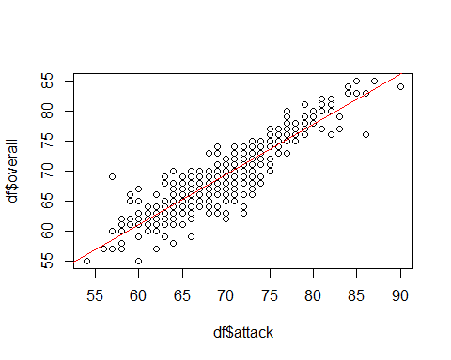
par(mfrow=c(2,2))
plot(m1)
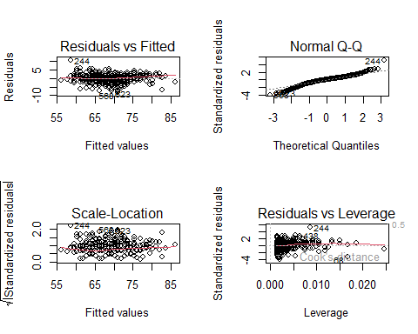
#MODELO LINEAL 2 (overall - midfield)
m2 <- lm(overall~midfield, data = df)
summary(m2)
##
## Call:
## lm(formula = overall ~ midfield, data = df)
##
## Residuals:
## Min 1Q Median 3Q Max
## -4.8633 -0.8633 0.0158 0.7740 4.4592
##
## Coefficients:
## Estimate Std. Error t value Pr(>|t|)
## (Intercept) 2.724984 0.593888 4.588 5.35e-06 ***
## midfield 0.959694 0.008654 110.895 < 2e-16 ***
## ---
## Signif. codes: 0 '***' 0.001 '**' 0.01 '*' 0.05 '.' 0.1 ' ' 1
##
## Residual standard error: 1.126 on 656 degrees of freedom
## Multiple R-squared: 0.9494, Adjusted R-squared: 0.9493
## F-statistic: 1.23e+04 on 1 and 656 DF, p-value: < 2.2e-16
plot(df$overall, df$midfield)
abline(a = m2$coefficients[1], b = m2$coefficients[2], col = "red")
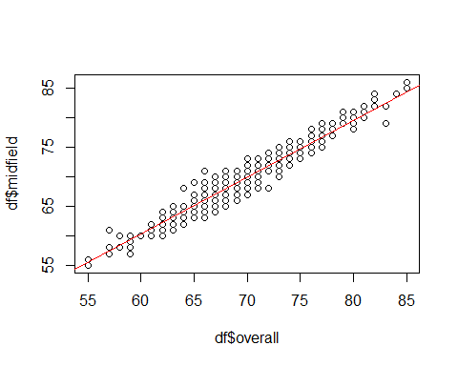
par(mfrow=c(2,2))
plot(m2)
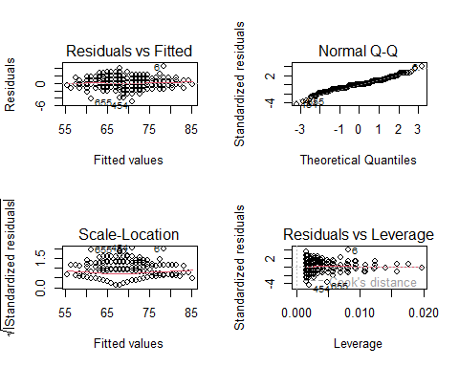
#MODELO LINEAL 3 (overall - defence)
m3 <- lm(df$overall~df$defence, data=df)
summary(m3)
##
## Call:
## lm(formula = df$overall ~ df$defence, data = df)
##
## Residuals:
## Min 1Q Median 3Q Max
## -2.7912 -0.7184 -0.2272 0.4999 6.4635
##
## Coefficients:
## Estimate Std. Error t value Pr(>|t|)
## (Intercept) 3.083597 0.613344 5.028 6.42e-07 ***
## df$defence 0.963613 0.009023 106.793 < 2e-16 ***
## ---
## Signif. codes: 0 '***' 0.001 '**' 0.01 '*' 0.05 '.' 0.1 ' ' 1
##
## Residual standard error: 1.167 on 656 degrees of freedom
## Multiple R-squared: 0.9456, Adjusted R-squared: 0.9455
## F-statistic: 1.14e+04 on 1 and 656 DF, p-value: < 2.2e-16
plot(df$overall, df$defence)
abline(a = m3$coefficients[1], b = m3$coefficients[2], col = "red")
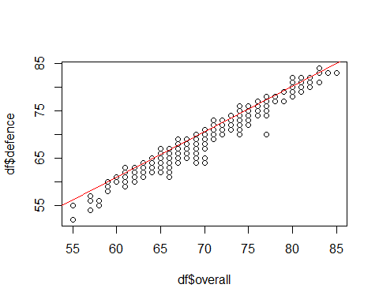
par(mfrow=c(2,2))
plot(m3)
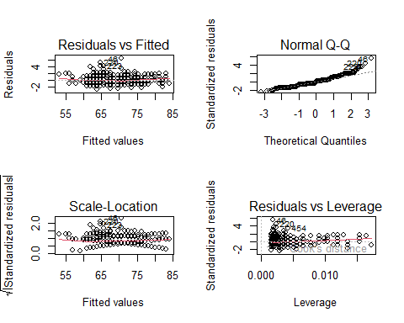
#MODELO LINEAL 4 (overall - attack + midfield)
m4 <- lm(overall~attack+midfield, data=df)
summary(m4)
##
## Call:
## lm(formula = overall ~ attack + midfield, data = df)
##
## Residuals:
## Min 1Q Median 3Q Max
## -4.1703 -0.5660 0.0091 0.5742 3.4855
##
## Coefficients:
## Estimate Std. Error t value Pr(>|t|)
## (Intercept) 1.81300 0.51797 3.50 0.000496 ***
## attack 0.21748 0.01467 14.82 < 2e-16 ***
## midfield 0.75449 0.01574 47.93 < 2e-16 ***
## ---
## Signif. codes: 0 '***' 0.001 '**' 0.01 '*' 0.05 '.' 0.1 ' ' 1
##
## Residual standard error: 0.9751 on 655 degrees of freedom
## Multiple R-squared: 0.9621, Adjusted R-squared: 0.962
## F-statistic: 8309 on 2 and 655 DF, p-value: < 2.2e-16
plot(df$overall, df$attack+df$midfield)
abline(a = m4$coefficients[1], b = m4$coefficients[2], col = "red")
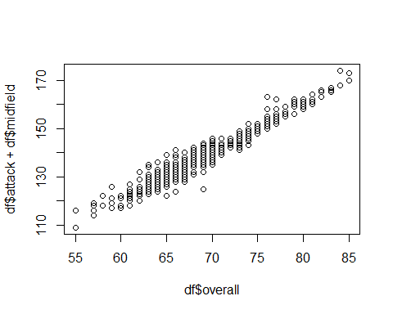
par(mfrow=c(2,2))
plot(m4)
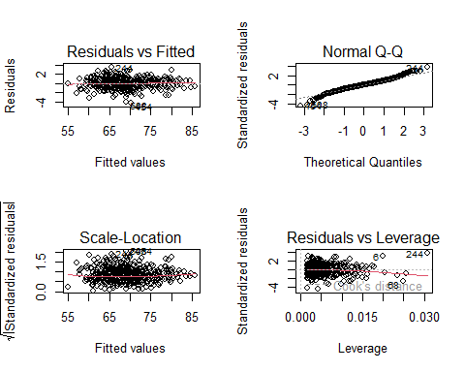
confint(m4, level = 0.95)
## 2.5 % 97.5 %
## (Intercept) 0.7959262 2.8300729
## attack 0.1886691 0.2462839
## midfield 0.7235814 0.7854004
#MODELO LINEAL 5 (overall - attack + midfield + defence)
m5 <- lm(overall~attack+midfield+defence, data=df)
summary(m5)
##
## Call:
## lm(formula = overall ~ attack + midfield + defence, data = df)
##
## Residuals:
## Min 1Q Median 3Q Max
## -1.9826 -0.4246 -0.0327 0.3614 2.6471
##
## Coefficients:
## Estimate Std. Error t value Pr(>|t|)
## (Intercept) 0.330568 0.336677 0.982 0.327
## attack 0.128379 0.009878 12.996 <2e-16 ***
## midfield 0.439358 0.014469 30.365 <2e-16 ***
## defence 0.430413 0.014119 30.485 <2e-16 ***
## ---
## Signif. codes: 0 '***' 0.001 '**' 0.01 '*' 0.05 '.' 0.1 ' ' 1
##
## Residual standard error: 0.6272 on 654 degrees of freedom
## Multiple R-squared: 0.9843, Adjusted R-squared: 0.9843
## F-statistic: 1.37e+04 on 3 and 654 DF, p-value: < 2.2e-16
par(mfrow=c(2,2))
plot(m5)
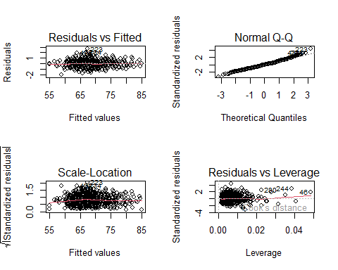
summary(m5)
##
## Call:
## lm(formula = overall ~ attack + midfield + defence, data = df)
##
## Residuals:
## Min 1Q Median 3Q Max
## -1.9826 -0.4246 -0.0327 0.3614 2.6471
##
## Coefficients:
## Estimate Std. Error t value Pr(>|t|)
## (Intercept) 0.330568 0.336677 0.982 0.327
## attack 0.128379 0.009878 12.996 <2e-16 ***
## midfield 0.439358 0.014469 30.365 <2e-16 ***
## defence 0.430413 0.014119 30.485 <2e-16 ***
## ---
## Signif. codes: 0 '***' 0.001 '**' 0.01 '*' 0.05 '.' 0.1 ' ' 1
##
## Residual standard error: 0.6272 on 654 degrees of freedom
## Multiple R-squared: 0.9843, Adjusted R-squared: 0.9843
## F-statistic: 1.37e+04 on 3 and 654 DF, p-value: < 2.2e-16
#prediccion de una nueva instancia, por ejemplo un equipo nuevo
predict(m5, interval = "prediction", newdata = data.frame(attack = 95, midfield = 87, defence = 87))
## fit lwr upr
## 1 88.1967 86.94133 89.45207

